**CLOUD MESSENGER**

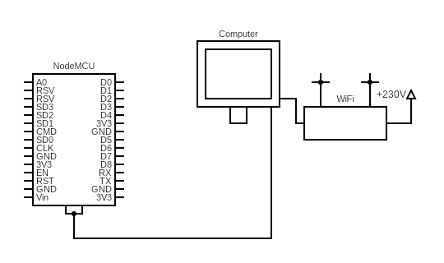**Circuit diagram:**

**Working of components**

**NodeMCU Board:**

The NodeMCU ESP8266 development board comes with the ESP-12E module containing the ESP8266 chip having Tensilica Xtensa 32-bit LX106 RISC microprocessor. This microprocessor supports RTOS and operates at 80MHz to 160 MHz adjustable clock frequency. NodeMCU has 128 KB RAM and 4MB of Flash memory to store data and programs. Its high processing power with in-built Wi-Fi and Deep Sleep Operating features make it ideal for IoT projects. NodeMCU can be powered using a Micro USB jack and VIN pin (External Supply Pin). It supports UART, SPI, and I2C interface. The NodeMCU Development Board can be easily programmed with Arduino IoT cloud web editor since it is easy to use. Programming NodeMCU with the Arduino IoT cloud web editor will hardly take 5-10 minutes. All you need is the Arduino IoT cloud, a USB cable and the NodeMCU board itself.

Once you have a personal account on the Arduino IoT cloud, login to your account using the username and password and connect the board with the computer using the USB cable. Now setup the things and dashboard on the cloud and open the Arduino IoT cloud web editor. Then choose the correct board by selecting Boards>NodeMCU 0.1ESP-12 Module (you may have to install a cloud agent for automatic detection of the board) and choose the correct Port. Once the code is loaded into your web editor, click on the ‘upload’ button given on the top bar. Once the upload is finished, you should see the successful output of your IoT project.